Joseph Silva Jr.

SNHU

CS 405: 4-1 Activity: Exceptions

11/20/2021

**Original Code Debug Results**

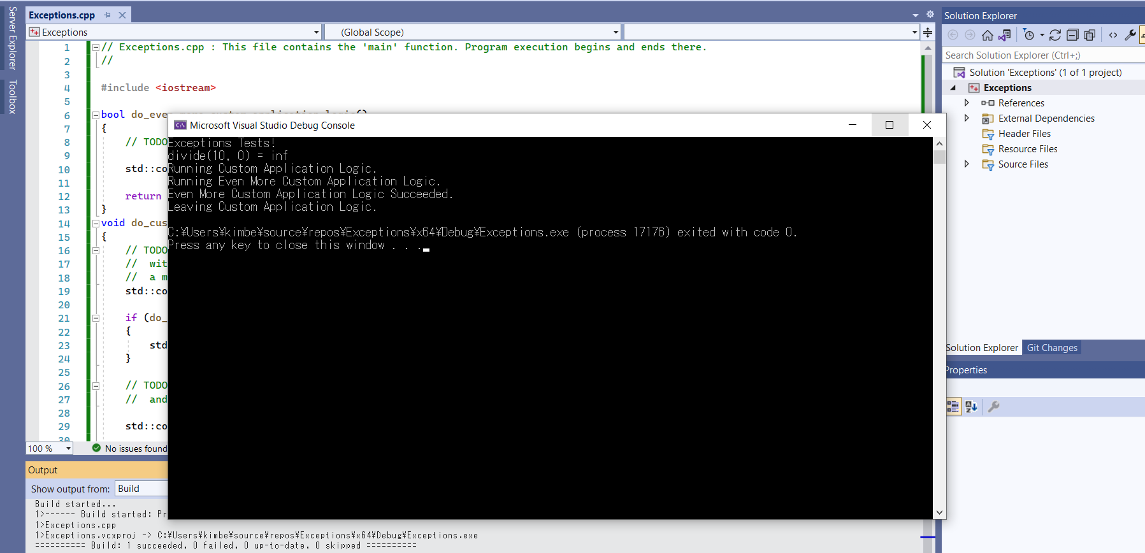

**Updated Code Debug Results**

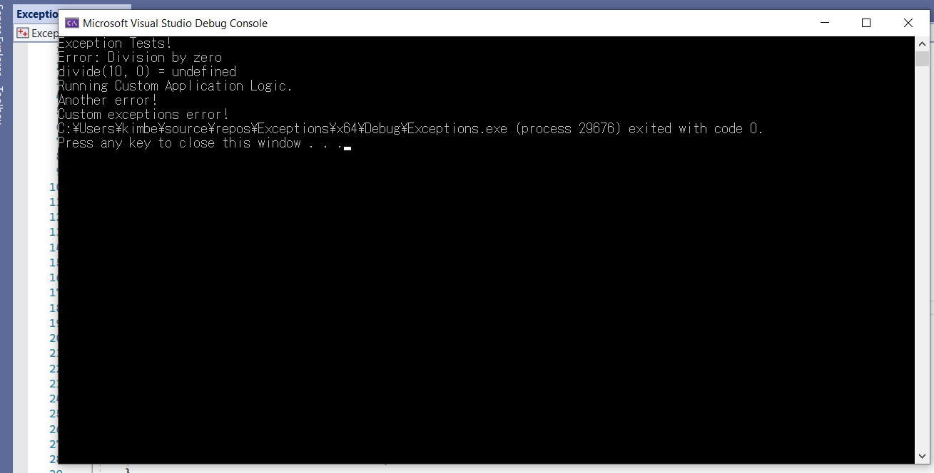

**Summary:**

When working with C++ coding, I usually refer to cppreference.com as a guide to follow to try different sets of code with the skeleton template I receive from class. The runtime_error and invalid_argument section of code defines a type of object to be thrown as an exception. These commands report errors whether it is because events go beyond the scope of the program, or the argument value wasn’t accepted. The try and catch method allows a block of code to be tested for errors while its being executed and then the block of code is defined if an error occurs.